Suggested Answers: Set 4

1.a) Wage(2 years education) = 5*(1.134)² = 6.43
Wage(9 years education) = 5*(1.134)⁴ *(1.101)⁴*(1.068)= 12.98

b) (6.43 – 5)/6.43 = 0.222 or 22.2% is attributed to human capital
(12.98 – 5)/12.98 = 0.614 or 61.4% is attributed to human capital

2. This is similar to supposing that country B is more polluted than country A, and for a given level of income, those in country A will be in better health than those in country B.

Hence, the curve h^{A}(y) for country A is situated above the curve h^{B}(y) for country B. If the two countries were otherwise identical then the revenue for country B would have to fall below that of country A: y_{B}’ < y_{A}. In order for the income per capita to be the same, we must reconcile this fact so that the curve y^{B}(h)must be further to the right than y^{A}(h). This could be due to a higher level of human or physical capital, or a higher level of efficiency or technology.

3. Since human capital, in the form of education, requires investment to create, a large youth population may not receive the necessary funding because the required investment cannot be adequately provided by the proportionately smaller workforce. Thus, the proportion of income needed to invest in proper education may not be forthcoming, since the total income will be limited.

4. Chap 16, no 5 of Blanchard: see pdf file sol_chap16_no5.PDF

Question #6
a) In the steady state (where k=K/AN):
γk^{1/2} = (δ + g_{N} + g_{A})k
Since δ = 0.1, γ = 0.16, g_{N} = 0.02, g_{A} = 0.04;

Take γk^{1/2} = (δ + g_{N} + g_{A})k and solve for k, capital stock per effective worker.
k^{1/2} = γ/(δ + g_{N} + g_{A}) → k^{ss} = [γ/(δ + g_{N} + g_{A})]²
→ k^{ss} = [0.16/(0.1 + 0.02 + 0.04)]²
→ k^{ss} = 1

y = k^{1/2}, sub in k^{ss} for k.
y^{ss} = (k^{ss})^{1/2} = [γ/(δ + g_{N} + g_{A})]
y^{ss} = 1

Growth rate of y^{ss} (y=Y/AN) in Steady state = 0
Growth rate of Y/N in Steady state = g_{A} = 0.04 or 4%
Growth rate of Y in Steady state = g_{A} + g_{N} = 0.06 or 6%

b) k^{ss} = [0.16/(0.1 + 0.02 + 0.08)]²
→ k^{ss} = 0.64
y^{ss} = 0.8
Growth rate of y^{ss} (y=Y/AN) in Steady state = 0
Growth rate of Y/N in Steady state = g_{A} = 0.08 or 8%
Growth rate of Y in Steady state = g_{A} + g_{N} = 0.1 or 10%

c) k^{ss} = [0.16/(0.1 + 0.06 + 0.04)]²
→ k^{ss} = 0.64
y^{ss} = 0.8
Growth rate of y^{ss} (y=Y/AN) in Steady state = 0
Growth rate of Y/N in Steady state = g_{A} = 0.04 or 4%
Growth rate of Y in Steady state = g_{A} + g_{N} = 0.1 or 10%

5. a)
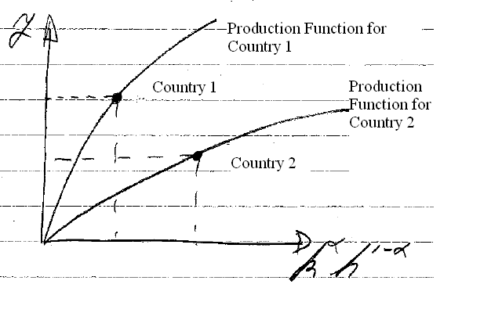
b)
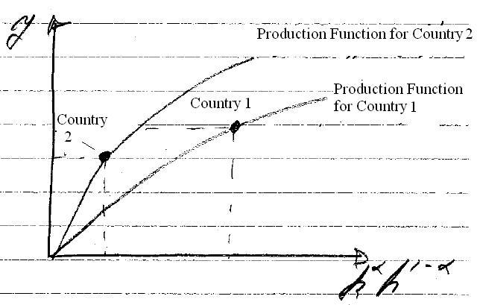

6. a) Since y_{i} = A_{i}k_{i}^{α}h_{i}^{1-α}
A_{i} = y_{i}/k_{i}^{α}h_{i}^{1-α} where α = 0.5

Therefore,
A₁ = y₁/k₁^{0. 5}h₁^{0. 5}
= 100/ (100)^{0.5}(25)^{0.5}
= 2
A₂ = y₂/k₂^{0. 5}h₂^{0. 5}
= 200/ (100)^{0.5}(64)^{0.5}
= 2.5

b) the output ratio when accumulated factor are the same:
y₁ = A₁k₁^{α}h₁^{1-α} / y₂= A₂k₂^{α}h₂^{1-α} → y₁/ y₂ = A₁/ A₂
→ = 2/2.5 = 0.8.
the output ratio of country 1 to country 2 would thus be equal to 80%.

c) If A₁ = A₂ , then y₁/ y₂ = k₁^{0. 5}h₁^{0. 5}/ k₂^{0. 5}h₂^{0. 5}
→ (100)^{0.5}(25)^{0.5}/ (100)^{0.5}(64)^{0.5} = 50/80 = 0.625.
The output ratio of country 1 to country 2 is thus 62.5%.

7. Since α=1/3 we have
y_{i} = A_{i}k_{i}^{1/3}h_{i}^{2/3}

Therefore, for Sweden:
y_{sw} = A_{sw}k_{sw}^{1/3}h_{sw}^{2/3} , y_{us}= A_{us}k_{us}^{2/3}h_{us}^{2/3}
→ y_{sw}/ y_{us} = A_{sw}/ A_{us} * (0.88)^{1/3}(0.91)^{2/3}/ (1)^{1/3}(1)^{2/3}
→ y_{sw}/ y_{us} = A_{sw}/ A_{us} * (0.9)
→ 0.67/0.9 = A_{sw}/ A_{us} = 0.744
We can also add (1 – 0.9)*100 = 10% and (1 – 0.744)*100 = 25%
Thus, factor accumulation explains that Sweden’s income is 90% that of the USA. Lower productivity in Sweden makes its income 74.4% that of the USA. In other words, the role of factor accumulation makes output 10% higher in the U.S. than in Sweden, and productivity makes output roughly 25% higher in the USA than Sweden. The productivity effect is thus 2.5 times more important in explaining why the Swedish are poorer.

For Mauritius:
y_{m} = A_{m}k_{m}^{1/3}h_{m}^{2/3} , y_{us}= A_{us}k_{us}^{2/3}h_{us}^{2/3}
→ y_{m}/ y_{us} = A_{m}/ A_{us} * (0.29)^{1/3}(0.67)^{2/3}/ (1)^{1/3}(1)^{2/3}
→ y_{m}/ y_{us} = A_{m}/ A_{us} * (0.507)
→ 0.49/0.507 = A_{m}/ A_{us} = 0.966
We can also add (1 – 0.507)*100 = 49.3% and (1 – 0.966)*100 = 3.4%
Thus, lower factor accumulation alone causes Mauritius to be 49.3% poorer than the USA, while lower productivity alone makes it 3.4% poorer. This means that in order to explain the lower income levels in Mauritius, lower factor accumulation is 14.5 times more important than its lower productivity.

For Jordan:
y_{J} = A_{J}k_{J}^{1/3}h_{J}^{2/3} , y_{us}= A_{us}k_{us}^{2/3}h_{us}^{2/3}
→ y_{J}/ y_{us} = A_{J}/ A_{us} * (0.18)^{1/3}(0.71)^{2/3}/ (1)^{1/3}(1)^{2/3}
→ y_{J}/ y_{us} = A_{J}/ A_{us} * (0.45)
→ 0.22/0.45 = A_{J}/ A_{us} = 0.489
We can also add (1 – 0.45)*100 = 55% and (1 – 0.489)*100 = 51%
Thus, the role of factor accumulation for Jordan in comparison to the U.S. is 45%. The difference due to productivity is 49%. In other words, the role of factor accumulation in output is 55% higher for the U.S. than in Jordan and the role of productivity in output is roughly 51% higher.

Notice that each country has less output per capita compared to the U.S. for different reasons. For some countries productivity is more important, for others factor accumulation causes a greater proportion of the disparity.

Thus, the role of factor accumulation in income in comparison to the U.S. is the largest for Sweden (90% of U.S.).

b) Productivity however, plays the largest role in income in comparison to the U.S. for Mauritius (96.6% of U.S.).

